Privacy Policy | 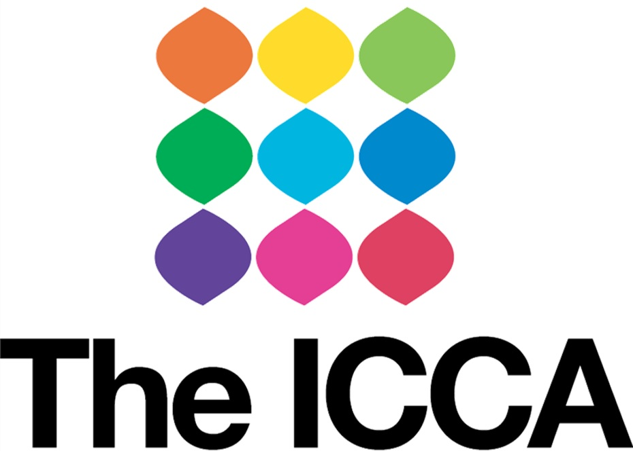

Aims
ICCA wants everyone who supports us, receives support from us, or works with us in any capacity to be satisfied with how any information relating to you will be gathered, and used.

Privacy Statement
We will not use your personal information in a way which you would not reasonably expect us to, and we will make every effort to make sure your information is processed in a fair and transparent manner.

We will ensure that we use your data in accordance with all relevant legislation.

This Policy has been written in line with the Data Protection Act 1998, and the EU General Data Protection Legislation (GDPR) 2016/679, and will explain;

- How we may collect your personal information
- The legal basis for us collecting data
- How we will use your data
- How and when we may disclose your details to others
- How your data is stored
- How your data is retained
- How your data is disposed of after use
- Your rights regarding the data we hold about you

Periodically it may be necessary for us to amend or update this Policy, an up to date version will always be made available to you via our website, www.theicca.co.uk or upon request via admin@theicca.co.uk or 0115 969 3402.

1 Definitions:

1.1 Personal Data
Personal data is any information relating to a natural person who can be directly or indirectly identified through that data.

1.2 Natural Person
Is an individual who can be identified, directly or indirectly, in particular by reference to an identifier such as a name, an identification number, location data, an online identifier or to one or more factors specific to the physical, physiological, genetic, mental, economic, cultural or social identity of that natural person.

1.3 Data Subject
A data subject is an individual who is the subject of personal data. In other words, the data subject is the individual whom particular personal data is about. Individuals who have died do not count as data subjects, nor does anyone who cannot be identified or distinguished from others via the data in question.

1.4 Sensitive Data
Sensitive Data is a special category of information concerning a data subject, and includes; racial or ethnic origin, political opinions, religious beliefs, trade union activities, physical or mental health, sexual life, or details of criminal offences.

1.5 Legal Bases
According to the GDPR personal data may only be collected and processed if you have a legal basis for doing so. The possible legal bases for data collection and processing are; consent, contract, legitimate interest, legal obligation, vital interest, or public task.

You should be aware on which legal bases your personal data is being collected and processed.
1.5.1 Consent
You have given clear consent for us to process your personal data for a
specific purpose.
1.5.2 Contract
The processing of your data is necessary for a contract you have entered into with us, or because you have asked us to provide you with a service or
product for which it is necessary to process your personal data.

1.5.3 Legitimate Interest
The processing is necessary for the legitimate interests of The ICCA or the legitimate interests of others unless there is a reason to protect your personal data which overrides this.
1.5.4 Legal Obligation
The processing is necessary for us to comply with the law.
1.5.5 Vital Interest
The processing is necessary to protect someone’s life
1.5.6 Public Task
The processing is necessary for us to perform a task in the public interest,
and it has a clear basis in law.

2. How we may collect your personal information:
The ICCA may collect your personal data in a range of ways, and for a number of reasons (outlined below), however we are committed to only gathering personal data which is necessary for us to be able to provide you with the best products and services from us.

2.1. Direct Information collection
You may choose to provide your personal information directly to us, which can happen either face to face, in writing or electronically. This may include; when you apply for a job, become a volunteer, register for or use one of our services, register for or attend an event, make a donation, offer us feedback, make a complaint, enter into a contract with us, and when you are captured by CCTV within our premises.

The data collected through these processes may commonly include your; name, contact details, information about your interests and experiences, education and qualifications, national insurance number, bank details, emergency contact details, your image and all information gathered by the visa team.

On occasion you may also be asked to provide us with sensitive personal data, which may include your; racial or ethnic origin, religious beliefs, physical or mental health, information about your gender and sexuality, and details of criminal offences you may have committed. Providing us with this information will usually be optional, unless there is a legal requirement for this information to be gathered.

2.2. Indirect Information Collection
You may interact with us through some of our social media accounts using platforms such as; Facebook, Instagram, Twitter, Snapchat, WhatsApp and LinkedIn, and through this we may obtain some personal information about you.

The information we receive through social media is controlled by the privacy settings on your own social media accounts. To control the information we receive about you through social media, you should review your settings and refer to the privacy policies of the social media sites you use.

2.3. Collecting Information Through Third Parties
The ICCA often delivers services with the aid of partners, subcontractors and other selected third parties, this means that sometimes your data will be collected by someone else who is working with us or under our instruction. If you are sharing personal data in this way you will be made aware of how your information is being collected and used by all parties concerned.

As well as applying directly, it is also possible to be referred to some of our services by third parties, in this instance someone who is known to you provides us with your personal information in order for us to be able to offer you any services which may be available and suitable for you. The person who is referring you to The ICCA will be responsible for letting you know how and why they are gathering your data, and for telling you that they will be providing this information to us.

2.4. Data Collected Via Our Websites
- Account Registration for WiFi access
- Form Submissions/ Enquiries
2.5. Data in the Public Domain
On occasion we may want to know more about the people we work with, and may use information which is freely available in the public domain to do this, for instance we may refer to data held with Companies House, The Charity Commission, or reported in the press and media. This data is not considered to be personal data under GDPR. We will only collect this type of data to help us understand how the goods and services we provide may be of most interest to you, and will remove this data from our records if you request us to do so.

2.6 Collecting Data from Children and Young People
If you are aged 18 or under we will always require you to provide us with permission from a parent/guardian before we collect any of your personal data.

3. Legal Bases for Collecting and/or Processing Your Personal Data
In line with GDPR, The ICCA recognises that it is only right and proper for us to collect and/or process your personal data if we have the legal grounds to do so.

GDPR sets out 6 legal grounds upon which your personal data can be processed, they are;
- Consent
- Contract
- Legitimate Interest
- Legal Obligation
- Vital Interest
- Public Task

In order for us to collect and/or process your personal data, we must first identify which legal bases apply, and this must be recorded formally.

Most commonly the data collection and processing undertaken by The ICCA will fall under the categories of; Contract, Legitimate Interest, Legal Obligation or Consent.

More information about each of the legal bases can be found in the definitions section of this policy on page 2.

4. How we Use Your Personal Data
The methods of data collection, and the ways in which The ICCA will use your data will vary depending on how we are working with you, the most common ways we may use your personal data are outlined below, however if we intend to use your data in any other way this will be discussed with you directly.

4.1 Provision of Goods and Services
When you ask us to provide you with good or services (for instance by signing up to one of our programmes, or registering for an event with us), your personal data will be collected in order to help us make sure you are receiving the most appropriate goods and services, and to help us deliver them to you in the most effective manner. On occasion we may also use your information to help us keep you informed about other areas of our work which may be relevant to you.

4.2 General Administration
It may be necessary for us to hold and use your personal data to help us to complete some essential administrative functions, such as responding to a complaint or other request you have raised.

4.3 Administration of Transactions
We may need to use our personal data to be able to complete transactions which occur because of your relationship with us, for instance; providing payroll services for The ICCA staff, the reimbursement of volunteer expenses or the processing of donations made to us or card payment transactions.

4.4 Processing Applications to Work with Us
If you apply to work with us in either a paid or voluntary capacity, we will collect and process your personal data in order to be able to manage your application, help us assess your suitability for the role applied for, and to respond to you.

4.5 Monitoring and Evaluation
We may use your information, and the feedback you give us to help us improve the goods and services which we provide both now, and in the future.

4.6 Provision of Our Websites and Online Services
We may use your personal information to provide you with access to our websites, and online service portals, and to help us personalise your online experience with us.

4.7 Legal Compliance
We may, on occasion be required to process your personal data due to the legal requirements placed upon us as a registered charity, for instance if you become a donor.

4.8 Prevention of Crime
Where necessary The ICCA may collect and process your personal information for the purposes of crime prevention, for instance by recording of your vehicle and your image and on CCTV.

4.9 Safeguarding (Protecting Your Vital Interests)
The ICCA holds a duty of care towards many of our service users, and however you interact with us we take your health, safety and welfare very seriously. If we believe that there is a serious risk of harm to you or someone else we may use your personal information to help protect you or them.

5. How and When We May Disclose Your Details to others
The ICCA will never share your information with third parties for their marketing purposes, unless you have consented, and we will never sell your data to others for any purpose.

5.1. Keeping you informed
We may use your contact details to keep you informed about the products and services which you have requested from us and any of our other products and services which we believe may be of interest to you. In order to do this your contact details may be shared between departments within The ICCA, however all of our staff and volunteers are bound by data protection legislation and this policy.

If at any time you would like us to change the way we use your data or contact you have the right to request this (please see sections 9 and 10 of this policy).

5.2 Evidence and Monitoring
The ICCA staff may use your information in order for us to review the success of our conferencing and private events, and the services which we provide. If this information is being shared outside of the programme you and a part of your information will be anonymised or aggregated with the data of other people so that you cannot be individually identified.

On occasion some of our commissioners who commission services to ICCA will require access to the personal data of participants to prove that we are funding the products and services agreed, and that we are working with eligible clients. If this is the case data sharing agreements will be in place and all parties will be governed by Data Protection laws, and your data will only be shared with them for this purpose.
5.3 Referral
Sometimes you might want to access services which we can’t offer you, or you might require some specialist support alongside the activities you are doing with us. Where this happens The ICCA staff may refer you to other service providers. We will make you aware of any such referrals before we make them, and you can ask us not to share your information in this way.

5.4 Quotes and Pictures
To help celebrate successes, and tell people about the products and services we offer we may ask you to provide quotes, or to be photographed during your activities, events or others at The ICCA. You can choose if you would like to do this and what information you would like to share if you do so.

Quotes and pictures may feature in the media, on our website, in reports and presentations we share, within our marketing materials, or on social media and therefore becomes information ‘in the public domain’ once published.

5.5 Safety and Legal Obligations
The ICCA takes the health, safety and welfare of our beneficiaries, staff, volunteers, and members of the public extremely seriously, and we have both a legal and moral obligation to act where any group or individual may be at risk of harm, or where a criminal act occurs.

We may share your personal information if we believe that you are at risk of harm from yourself or others, or if we are required to do so by the law.

6. How Your Data is Stored
The ICCA take appropriate organisational, technological and behavioural steps to keep your information safe however that information is shared with us, and in whatever format.

6.1 Online Data
A number of our services use secure web based portals to collect and store your data, the information collected in this way is stored to ‘cloud’ services. Our cloud storage services are located within the UK, so we do not transfer your information outside of the European Economic Area, and all of our service providers are covered by UK and EU data protection laws.

6.2 Electronic Files
All of our programmes retain electronic files which are stored locally on The ICCA’s own servers, servers are protected by firewall software, and are securely backed up to our cloud servers which are based in the UK.

Access to files on The ICCA’s servers is further limited by a system of permissions and passwords meaning that your personal information should only be accessible by permitted individuals and accessed on a need to know basis.

6.3 Electronic File Transfer
Where personal data is transferred via e-mail or other electronic transfer The ICCA usually uses a system of encryption to protect that data. Should it not be possible to use encryption personal data will only be transferred as a password protected on sensitive document file, and passwords will never be transmitted with the data that will grant access to the data.

6.4 Paper Files
Some of our activities and programmes require us to keep paper based records, which may include those containing personal data (such as personnel records for our staff and volunteers). The ICCA aims to minimise the amount of personal data kept in this manner, and ensures that all of it’s offices are equipped with secure storage for files containing personal data.

7. How Your Data is retained
The specific amount of time your personal data will be retained for is dependent upon the reasons why your data has been collected and stored by us; however we aim to keep your information for no longer than is absolutely necessary.

Some types of information must also legally be retained for set periods of time; in line with best practice The ICCA will retain your information for the legally required minimum term plus up to 5 calendar years. If you would like to know more about the periods for which your information must be kept by us, please refer to the Data Retention Policy.

8. How Your Data is Disposed of After Use
The method which will be used to dispose of your personal data will vary depending on the type of documents stored, the methods by which they have been collected/stored, and the other information held with them.

8.1 Deletion
Where it is possible to undertake electronic deletion of your information we will do so in full within 5 years of the end of the minimum retention period. This will include electronic copies stored both locally and within the cloud.

8.2 Destruction
If your personal data is stored in hard copy (on paper, or other media such as CD rom) within 5 years after the end of the minimum retention period your data will be physically destroyed in a way which prevents it’s future use or your further identification. This is usually achieved through the use of confidential waste shredding services.

8.3 Anonymisation and Pseudonymising
Some kinds of data may need to be retained for business purposes beyond the period for which we must retain your personal information. If this is the case, within 5 years of the end of the minimum retention period any such data will be modified so that the information cannot be used to identify individuals. This may be achieved through anonymising information (removing your identifiable details), or Pseudonymising it (using artificial identifiers to indicate individuals such as a code number instead of names).

9. Your Rights Regarding the Data We hold About you
Under GDPR individuals have a number of rights regarding their personal data, some of these are general rights which apply to all of your personal data, and some of these rights vary depending upon which legal bases apply to the processing of your personal data.

9.1 General Rights
In all circumstances you have the right to be informed about the data we hold regarding you (right of transparency), the right to access the data we hold about you (the right of access), and you have the right for the information we hold about you to be accurate, and to be amended to make it accurate if it is not (the right of rectification).

9.2 Right to withdraw consent
If we have used the legal basis of Consent to process your personal data, you are legally able to withdraw your consent at any time meaning that we can no longer use your data for the agreed purposes. Depending on what data is held and how this will result in your data either being archived, destroyed or anonymised to protect your wishes and your identity.

9.2 Right to have your data erased
This is also known as ‘The Right to Be Forgotten’, this applies if your data has been processed on the basis of either Consent or Legitimate Interest, your data is no longer required for the original purposes, or your data is being used for marketing purposes to which you object.

9.3 Right to restrict the use of your data
The right to restrict the use of your data means that you can ask us to hold your information, but not to use it, this would normally be a temporary measure, and only applies to processing of our information under the legal bases of Contract, Consent and Legitimate Interest.

9.4 Right to data portability
If your data is stored in a transferable electronic format you may wish for us to transfer this information to someone else so that you don’t have to provide the information more than once. You have the right to do this if your personal information has been collected using the legal bases of Consent or Contract, and if it is in a portable format.

9.5 The right to object
If your data has been processed under the legal bases of Legitimate Interest or for the purposes of completing a task in the public interest then you have the right to object to it’s processing. You can also object if your data is processed for research or direct marketing purposes which you do not want to be included in.

9.5 Your rights regarding automated decision making and profiling
Automated profiling and processing refers to computerised assessments of your data which don’t involve a human decision maker, your information can only be processed in this way based on the legal bases of Consent or contract.

Some of our programmes use automated decision making processes to assess things such as eligibility based geographical data, we do not use automated decision making in other ways.
10. Contacting us regarding your data
If you would like to know more about our data processes, how we hold or use your information, or if you would like to exercise any of your rights under Data Protection Legislation please contact our Data Protection Officer, whose details are;

The Atrium
99 Hucknall Road
Carrington
Nottingham
NG5 1QZ

Tel: 0115 969 3402
E-mail: admin@theicca.co.uk

